TRANSPORTATION PROBLEM
TRANSPORTATION PROBLEM USING NORTHWEST METHOD

AIM: TO WRITE A PROGRAM IN PYTHON TO DEMONSTRATE TRANSPORTATION PROBLEM USING NORTHWEST METHOD.
PROGRAM:
# Northwest Corner Method - step-by-step
# Problem data (from your sheet)
# Costs matrix: rows = origins O1,O2 ; cols = destinations D1,D2,D3
costs = [
[8, 6, 10], # O1
[10, 4, 9] # O2
]

supply = [2000, 2500] # supplies for O1, O2
demand = [1500, 2000, 1000] # demands for D1, D2, D3

# Make copies so we don't destroy originals if we want to reuse them
sup = supply.copy()
dem = demand.copy()

# Prepare an allocation matrix initialized to zeros
alloc = [[0 for _ in range(len(demand))] for _ in range(len(supply))]

print("Northwest Corner Method - step by step\n")
print("Initial supply:", supply)

print("Initial demand:", demand)
print()
i = 0 # origin index (row)
j = 0 # destination index (col)
step = 0

# Loop until all supplies and demands are satisfied
while i < len(sup) and j < len(dem):
step += 1
qty = min(sup[i], dem[j])
alloc[i][j] = qty
sup[i] -= qty
dem[j] -= qty

# Print step details
print(f"Step {step}: Allocate {qty} units to cell O{i+1}, D{j+1}")
print(f" cost per unit = {costs[i][j]}")
print(f" Remaining supply for O{i+1} = {sup[i]}")
print(f" Remaining demand for D{j+1} = {dem[j]}\n")

# Move to next row or column (if supply exhausted move down, if demand exhausted move right)
# If both become zero, move one and then the other: standard choice is to advance column (j) after row
if sup[i] == 0 and dem[j] == 0:
# If both exhausted, advance (commonly advance row or column) - advance column then row to avoid skipping
# But we must ensure not to go out of bounds: handle carefully:

# Advance column if possible, otherwise advance row.
if j + 1 < len(dem):
j += 1
elif i + 1 < len(sup):
i += 1
else:
break # Finished
elif sup[i] == 0:
i += 1
elif dem[j] == 0:
j += 1
# This else normally won't happen because qty = min(sup[i], dem[j]) forces one to zero
else:
pass

# Display final allocation matrix
print("Final allocation matrix (rows = O1,O2 ; cols = D1,D2,D3):\n")
header = [" |"] + [f" D{c+1}" for c in range(len(demand))] + ["| Supply"]
print("".join(header))
for r in range(len(alloc)):
row_str = [f"O{r+1}|"] + [f"{alloc[r][c]:6d}" for c in range(len(alloc[r]))] + [f"| {supply[r]:6d}"]
print("".join(row_str))
print()

# Compute total cost
total_cost = 0
for r in range(len(alloc)):

for c in range(len(alloc[0])):
total_cost += alloc[r][c] * costs[r][c]
# Print non-zero allocations
print("Allocations (non-zero):")
for r in range(len(alloc)):
for c in range(len(alloc[0])):
if alloc[r][c] != 0:
print(f"O{r+1}, D{c+1} -> {alloc[r][c]} units at cost {costs[r][c]} => contribution = {alloc[r][c] * costs[r][c]}")

print(f"\nTotal transportation cost (initial NW-corner solution) = {total_cost}")

OUTPUT:
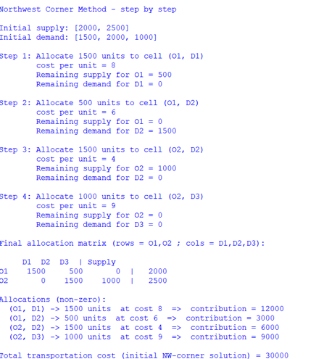
CONCLUSION: THE ABOVE PROGRAM HAS BEEN EXECUTED SUCCESSFULLY.

